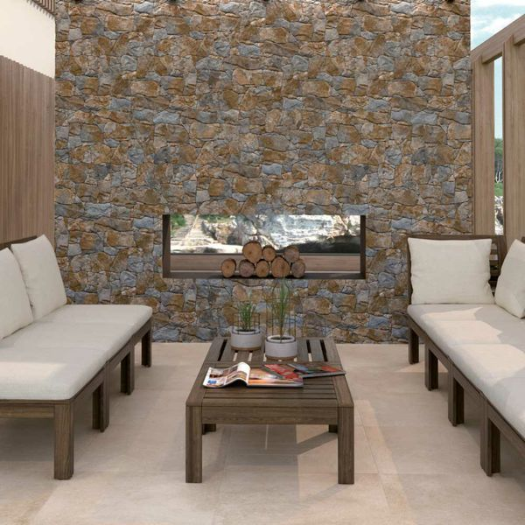**Stacked Rustic Slate Stone:**

## **Product Description**

Inject the natural look into your home with these striking Stacked Rustic Slate Stone Effect Tiles. They allow you to create the illusion of stacked drywall; the type you might find in a country farmhouse. They are perfect for creating a feature wall in a kitchen, bathroom or living room. Because they're made from porcelain, they can even be used outside to clad a garden wall. They have a matt finish. They're suitable for use in both internal and external wall spaces. For a grout that matches the faux grout joint contained within these tiles, try our [Ultracolour Plus, Black Tile Grout](https://www.wallsandfloors.co.uk/catrangetiles/tile-grouts/mapei-grouts/mapei-ultracolour-plus-black-120-grout/17841/).

## **Product Info**

* Product ID: 15312
* Tiles Per SQM: 4.6200046200046
* Sale by: Per SQM
* Size: 650x333x10mm
* Weight: 4.20 KG
* Material Type: Porcelain
* FinishMatt
* Colour: Multicolour
* Suitability: Walls
* Grade: 4
* Rectified Edge: No
* Underfloor Heating: No
* Thickness (mm): 10